Exercise:

1. Display Product’s name and their supplier’s name (ContactName), whose supplier’s name does not contain “A” and there should be at most 10 characters in Product’s name.

Solution:

use Northwind;

SELECT p.ProductName, s.ContactName AS SupplierName

FROM Products p

INNER JOIN Suppliers s ON p.SupplierID = s.SupplierID

WHERE LEN(p.ProductName) <= 10

AND s.ContactName NOT LIKE '%A%'

Output:

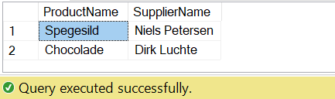

1. Create a report showing order ID., OrderDate, EmployeeID, and the firstname and LastName of the associated Employee. (Tables: Employees & Orders )

Solution:

use Northwind;

SELECT o.OrderID, o.OrderDate, o.EmployeeID, e.FirstName, e.LastName

FROM Orders o

INNER JOIN Employees e ON o.EmployeeID = e.EmployeeID;

Output:



1. Count no of Products’s against each Suppliers name. List only those products whose count is less than 5.

Solution:

use Northwind;

SELECT s.CompanyName AS SupplierName, COUNT(p.ProductID) AS ProductCount

FROM Products p

INNER JOIN Suppliers s ON p.SupplierID = s.SupplierID

GROUP BY s.CompanyName

HAVING COUNT(p.ProductID) < 5;

Output:

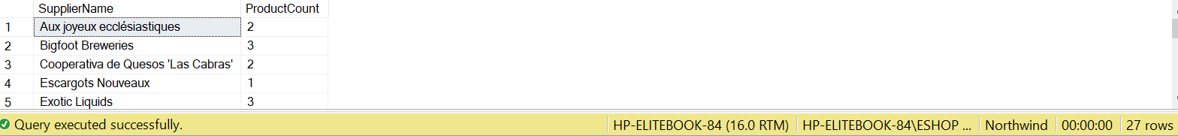

1. Display Titles and their quantity. Show only those records where quantity is less than 10 (Hint Pubs database, table title and sales).

Solution:

use pubs;

SELECT t.title, s.qty

FROM titles t

INNER JOIN sales s ON t.title_id = s.title_id

WHERE s.qty < 10;

Output:

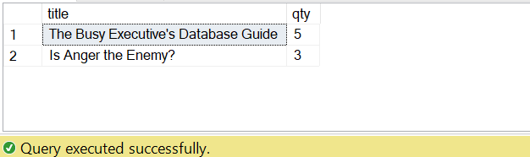

1. Display Book Title and publisher Names (pubs Database, Table Title and Publisher).

Solution:

use pubs;

SELECT t.title, s.qty

FROM titles t

INNER JOIN sales s ON t.title_id = s.title_id

WHERE s.qty < 10;

Output:

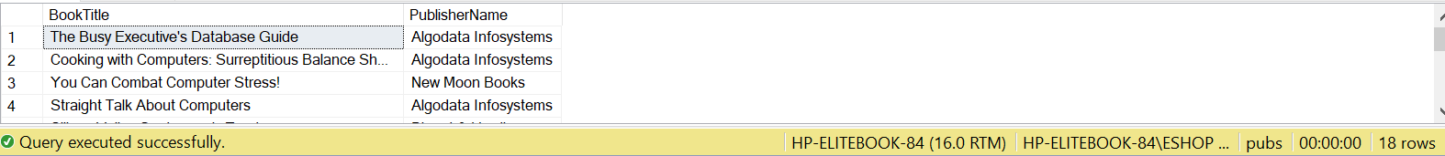

1. Display name of those publishers who haven’t published any book yet.

Solution:

use pubs;

SELECT p.pub_name AS PublisherName FROM publishers p LEFT JOIN titles t ON p.pub_id = t.pub_id WHERE t.pub_id IS NULL;

Output:

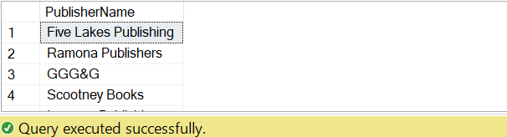

1. Display Authors name whose city is same (Author id should be different).

Solution:

use pubs;

SELECT t.title, s.qty

FROM titles t

INNER JOIN sales s ON t.title_id = s.title_id

WHERE s.qty < 10;

Output:

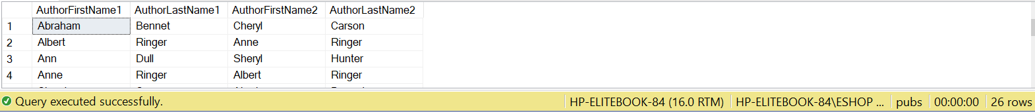

1. Use cross join (Cartesian join) to Display Book Title and Publisher Name.

Solution:

use pubs;

SELECT t.title AS BookTitle, p.pub_name AS PublisherName

FROM titles t

CROSS JOIN publishers p;

Output:

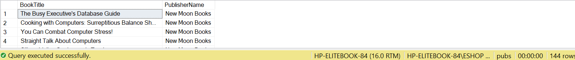

1. Use two full joins to Display Product Name, Category Name and Supplier Name.

Solution:

use Northwind;

SELECT

p.ProductName,

c.CategoryName,

s1.CompanyName AS SupplierName

FROM

Products p FULL JOIN Categories c ON p.CategoryID = c.CategoryID FULL JOIN Suppliers s1 ON p.SupplierID = s1.SupplierID;

Output:

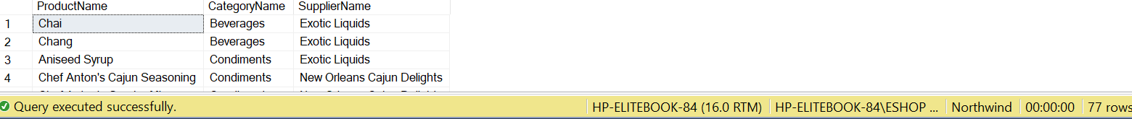

1. Write a query to list the names of employees that belongs to the same location as the employee named Nancy.

Solution:

use Northwind;

SELECT FirstName + + LastName [Employee Name]

FROM Employees

WHERE City = (SELECT City FROM Employees WHERE FirstName = 'Nancy');

Output:

